Chapter 14, Solution 38.

Find the resonant frequency of the circuit in Fig. 14.78.

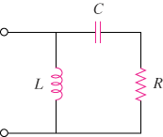

Figure 14.78
For Prob. 14.38.

Solution

Thus,

